**Global sales Data Analytics**

|  |  |
| --- | --- |
| **Date** | 15-11-2022 |
| **Team id** | PNT2022TMID45267 |
| **Project Name** | GlobalsalesDataAnalytics |

**Sales Dashboard**

**Executive Sales Dashboard**

**Executives need to quickly assess and share core sales KPIs such as closed revenue, opportunity status, performance vs quota trends and top closed and open opportunities in the current quarter.Effective sales dashboards allow sales and RevOps executives to easily track their team’s progress toward goals, manage pipeline and identify issues, and set forecasts based on data they trust. Sales leaders are highly visible in their organizations and these dashboard examples help them quickly communicate performance to all stakeholders**

**Sales Budget KPIs Dashboard**

**Naturally, sales leaders track revenue. But they also have to track management metrics like expenses vs target and account receivable percentage. And they need to be able to explore the data by year, segment, region, sales rep and product group. Modern dashboards integrate data from multiple sources to present these KPIs in one place**

**Sales vs Margin Dashboard**

**Sales executives are accountable to profitability, not just top-line revenue. This sales analysis dashboard provides the sales vs margin by salesperson as a holistic visualization and allows the executive to drill into each reps performance**

**Sales Performance and Productivity Dashboard**

**Sales execs need a dashboard that gives a complete picture, from macro-level down to individual-level performance, all on one screen. This sales dashboard example allows them to easily drill into data to analyze the health of their pipeline by region, industry, job function or 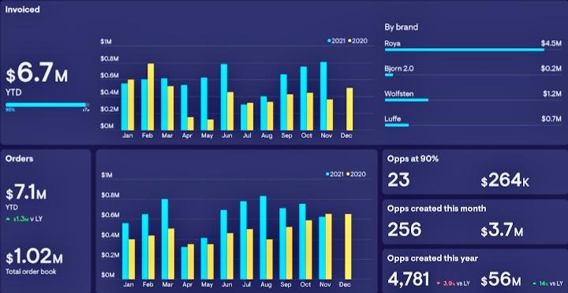sales representative**